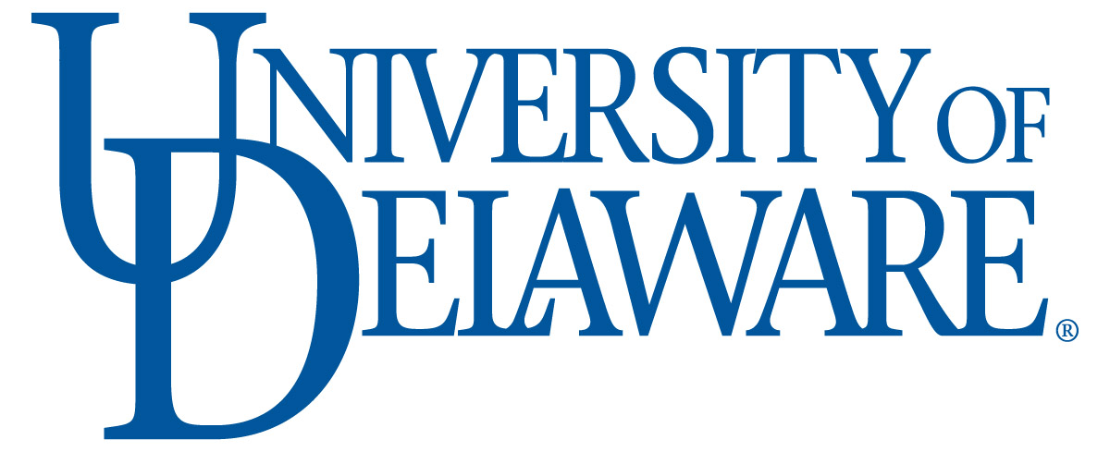 | Biotechnology PSM Internship  Interim Evaluation Form for Employers | 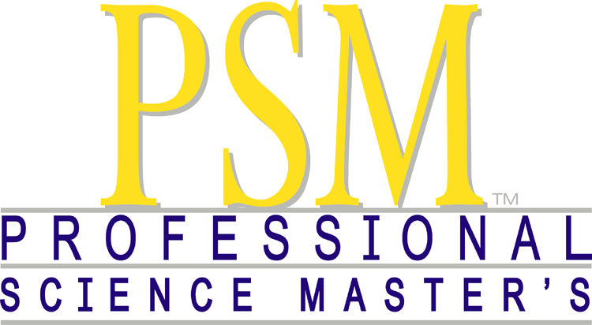

Student Name: |  |  |  |  | Date:
Company/Organization:
Supervisor: |  |  |  |  | Phone #:
Is the intern working on a project or performing work identified in the Internship Definition Document?
Yes: |  |  | No:
Please describe the project and/or your intern's responsibilities if different from planned responsibilities:

On a scale of 1 – 5, where 1 is low and 5 is very high, please rate your level of satisfaction in the intern’s performance level:
1: | 2: | 3: |  | 4: |  | 5:
Comments & Feedback (please use this space to address any issue that need to be resolved):

Please return this form to: Melinda Duncan, Program Director
Department of Biological Sciences
Wolf Hall
University of Delaware
Newark, DE 19716
OR email duncanm@udel.edu

